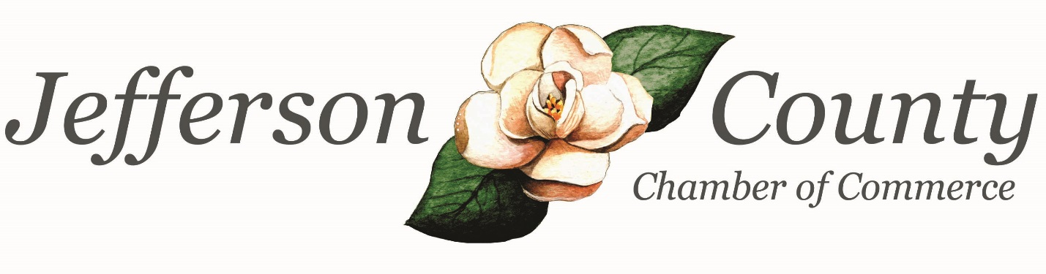

2018 Annual Report
Jefferson County Chamber of Commerce

A Year in Review

Chamber Transition
Early 2017 brought the resignation of 17-year Chamber President, Lil Easterlin. Lil decided it was time to dedicate her full-time efforts to the Development Authority of Jefferson County. With that decision, Amy Howard was hired to fulfill the Chamber’s vacancy as President. We are 18-months in and as busy as ever!

Programming & Events
What an eventful year - Casino Night, STAR Student Banquet, the Community Update Series and an outdoor Annual Meeting filled with music and barbeque! It has been an event-packed year and one I hope you’ll enjoy reviewing within the pages of this report.

Operating Highlights
2018 was a year of social connection and community awareness! The Chamber blasted lots of announcements and information to its members via email, Facebook and Instagram. The Chamber’s newly designed website was launched in early spring. On it you’ll find program details, a member directory and other lots of other valuable information! New programs were also added: Youth Leadership Jefferson County, HR Roundtable, First Friday Coffees and the ever-popular Community Update series focusing on 7 different facets of the community throughout the year.

Looking Ahead

So, What’s Next?
2019 is filled with promise! A new county map is one project the Chamber will begin working on in the new year. The Chamber is also looking forward to hosting a Business Builder Series of Lunch & Learns as well as workshops, Leadership Jefferson and a Casino Night themed New Orleans-style!

Our Mission
- To pursue those activities which create and support a business environment conducive to enhancing the prosperity of the commercial, industrial, residential and retail elements of Jefferson County in order to advance a civic, economic, cultural and social betterment for and through our members.

Who Are Our Members?

The Industries and Professional Services, Restaurants & Retail categories are small businesses. Small businesses are defined as employing 500 or less.
Chamber Details
Our 2018 programs & events were attended by 1000+ attendees!

7 Community Updates
Jefferson Hospital • Economic Development • Municipalities • Jefferson County Board of Education • County Budget • Public Safety • Dept. of Transportation
Public Speaking Workshop
Presented by Michael Howard
Google Workshop
Presented by Official Google Trainer, Demming Bass
Legislative Breakfast
Senator Jesse Stone• Representative Mack Jackson • Representative Brian Prince
STAR Student Banquet
County STAR Student – Luke Rodgers • County STAR Teacher – Tommy Browne
Annual Meeting
Music • Barbeque
Casino Night
Are You Ready for Some Football • Chamber’s Annual Fundraiser
4 HR Roundtables
@ Battle Lumber Company – Series Expectations & Goals • @ Queensborough – Employment Laws •
@ Jefferson Hospital – Employee Healthcare • @ Jefferson County High School - Workforce
Community Shred Day
In partnership with Queensborough National Bank & Trust Company
Cemetery Tour
In partnership with Jefferson County Historical Society
3 First Friday Coffees
Networking Opportunity for Chamber Members
5 Ribbon Cuttings
Redeemed Automotive • Something Wonderful • JK & Company • Jefferson Hospital Rehabilitation Center • Mulberry & Magnolia
Youth Leadership Jefferson County
Introducing our Youth to Jefferson County industry, local governmental agencies and fine-tuning soft skills.

Community Shred Day
3 Hours of Shredding = 3850 lbs Shredded
Environmental Savings:
32 trees
13,475 Gallons of water
9.6 cubic yards of landfill space

Casino Night
$2,704.49 raised & reinvested in our community to assist with funding of Chamber programs & events!

2017-2018 Youth Leadership Jefferson County
18 Students
32 Speakers
16 Visits & Tours
431 Community Service Hours
50 Council and/or Commission Meetings Attended

LaTia Berry • Tyreik Carlyle • Jennifer Dudley • Warthen Evans • Dawson Gardner • Juasia Hiers • Evans Hodges • Amaiya Hunt • Sreshta Jahnu • Anushka Jhaveri • Thomas Knight • Remington Mathis • Alysia Mills • Taylor Palmore • Brinson Raley • Tripp Smith • Logan Wasden • Alaylla Watkins

Chamber of Commerce Partners

The Chamber worked with many community partners in 2018!

ARDA
Blaze
Bustlin’ on Broad
Buzzard Blast
City of Louisville
City of Wadley
City of Wrens
Classic South Tourism
CSRA Regional Commission
Downtown Business Merchants
Drugs Don’t Work
GA Chamber of Commerce
Jefferson County Commission
Jefferson County Development Authority
Jefferson County High School
Jefferson County Historical Society
Jefferson County Rotary Club
Jefferson Energy Cooperative
Jefferson Hospital
Jefferson Hospital Foundation
KaMin
Louisville Downtown Development Authority
Louisville Food Pantry
Louisville Kiwanis Club
NextSite 360
Oconee Fall Line Technical College
Peachtree Publishing
Queensborough
SHIPS for Youth
Small Business Development Center
SOR (State of the Region)
The News and Farmer
Thomas Jefferson Academy
WPEH

2018 Executive Board of Directors

Rosie Burge, Chairman
Bartow Community Club

Parish Howard, Vice-Chairman
The News and Farmer

Brent Dye, Secretary
Integrated Healthcare Resources

Ric Miller, Treasurer
First State Bank

Billy Valduga, Past-President
State Farm Insurance Agency

2018 Board of Directors

Tesie Bowles, Queensborough National Bank and Trust Company
Amber Dowdy, Thomas Jefferson Academy
Jennifer Eubanks, To the Top Youth Center
Jessica Guy, Jefferson Hospital
Matt Hodges, Oconee Fall Line Technical College
Tammy Hodges, Jefferson County High School
Charles Mathis, Jefferson Energy Cooperative
Sandi Shields, BEST Office Solutions
Rob Swan, Battle Lumber Company

Thank you to the Chamber’s 2018 sponsors!

2018 Chairman’s Circle Sponsors
Queensborough National Bank and Trust Company
First State Bank
Battle Lumber Company
This group sponsored ALL 2018 Chamber events.

Gold Sponsors
Jefferson Energy Cooperative
Sponsored Legislative Breakfast

Magnolia Sponsors
The Bookworm
Jefferson County Rotary Club
Louisville Kiwanis Club
This group sponsored the STAR Student Luncheon.

BEST Office Solutions
Sponsored Women in Business Luncheon

Chamber sponsors are committed to providing support for community and business success. Sponsoring Chamber events and programs provides your business publicity and brand recognition at Chamber events while building lasting relationships and allowing you to give back to the community.

