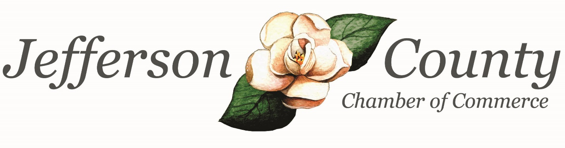

2019 Annual Report
Jefferson County Chamber of Commerce
November 19, 2019

All –

Has it really been 2 ½ years I’ve been at the Chamber? I’m thankful for the Chamber’s amazing community partners, active members and a board that supports the Chamber in all its efforts.

December 2019 will mark the completion of Chamber Board Chair Rosie Burge’s term in office. Parish Howard will fill the role of Chair for 2020-2021. Thank you, Rosie, for your hard work and dedication to the Chamber! The board works diligently throughout the year and the Chamber is more effective because of this group of individuals! A full list of board members and the businesses they represent is listed within this report.

2019 has been a year of connectivity and resources! What an impact we are having on this community! It has been an event-packed year and one I hope you’ll enjoy reviewing within the pages of this report.

Programming & Events
2019 included a New Orleans themed Casino Night, STAR Student Luncheon, Business Builder Series, Resource Expo and another outdoor Annual Meeting! Proceeds from Casino Night, the Chamber’s annual fundraiser, are placed directly back into the community through our programming and events.

The Chamber hosted several new events in 2019 including a Resource Expo. Twelve local and regional vendors set up displays showcasing their services. Chamber and community members attended and learned how these services can help their business. The Chamber also partnered with the Small Business Development Center for a Customer Service Workshop. This engaging and interactive workshop included a local panel, role-play and allowed in-depth conversation about customer service.

Another new event in 2019? How about a Professional Headshot Session? This complimentary service was provided by one of our very own Chamber members. Another? Talk and Tacos. This networking event allowed for great conversations between Chamber members.

Operating Highlights
Within its Business Builder Series, the Chamber provided information, connectivity and resources in various elements of the business world – fraud, digital marketing, conflict management, cybersecurity and financial literacy. Our Human Resources Roundtable met quarterly, building a network of like-minded professionals who face similar tasks and challenges, albeit through varying businesses.

The Chamber also updated its membership management software to streamline your registration process and allow for not only online registration but also online payments. Included in the new software is the Member Information Center, a member-only portal where members can post company information, specials, update contact information and more!

So, What’s Next?
2020 is filled with vision and opportunity! There are several series of luncheons planned to give you more of an in-depth view of topics important to your business. Want to better understand your membership benefits? Join us for Membership 101!

Want an app for your iPhone or android to keep up with happenings at the Chamber? One will be available for you. The Census is April 1, 2020! The Chamber is partnering with the Complete Count Committee to aid in this effort. Youth Leadership Jefferson County will also kick-off in the spring!

Of course, our foundational events like the STAR Student Luncheon, Casino Night, County Budget Luncheon, First Friday Coffees, Annual Meeting and Legislative Breakfast will remain.

What an impact we are having on this community! Looking forward to 2020 and providing just what you need to better your business and your community!

Kindest regards,

Amy Howard
President
Jefferson County Chamber of Commerce

Our Mission
- To pursue those activities which create and support a business environment conducive to enhancing the prosperity of the commercial, industrial, residential and retail elements of Jefferson County in order to advance a civic, economic, cultural and social betterment for and through our members.

Who Are Our Members?

The Small Business category comprises our professional services, restaurants and retail. Small businesses are defined as employing 500 or less.
Although our industries are small businesses, they are listed separately for the purpose of this report.

Chamber Details
Our 2019 programs & events were attended by 1000+ attendees!

5 Business Builder Lunch & Learns
Fraud • Digital Marketing • Conflict Management • Financial Literacy • Cybersecurity
Annual County Budget Lunch & Learn
Presented by County Administrator Adam Brett
Resource Expo
12 Vendors Sharing Information with Our Community
Legislative Breakfast
Senator Jesse Stone• Representative Mack Jackson • Representative Brian Prince
STAR Student Banquet
County STAR Student – Cole May • County STAR Teacher – Valerie Roberson
Customer Service Workshop
In partnership with SBDC
Professional Headshot Session
Chamber members were able to obtain professional, complementary headshots
Annual Meeting
Live Music • Food • Drink • Annual Report
Casino Night
A Night in New Orleans • Chamber’s Annual Fundraiser
3 HR Roundtables
@ Jefferson Energy Cooperative – Employee Engagement • @ Gatherings – Dept. of Labor Services •
@ Fulghum Industries – Financial Literacy
Community Shred Day
In partnership with Queensborough National Bank & Trust Company and Jefferson Hospital
3 Hours of Shredding = 4800 lbs Shredded
2 First Friday Coffees
Networking Opportunity for Chamber Members

Talk & Tacos
Networking opportunity at El Centenario Mexican Bar & Grill
9 Ribbon Cuttings
ABC Women’s Clinic • Pineland TelCo • Whitestone Transportation • Louisville Community Food Pantry • Jefferson Hospital Wrens Rehabilitation Clinic • Fraser Roofing • Team Universe Cheer • Felicia’s Hot Wings & More • Broad Street Books
Youth Leadership Jefferson County
Introducing our Youth to Jefferson County industry, local governmental agencies and fine-tuning soft skills. Our second Youth Leadership Jefferson County students graduated in March 2019.
Leadership Jefferson
Twelve participants diving into the County’s government and industry while strengthening leadership skills.
Casino Night
$5,080.95 raised & reinvested in our community to fund Chamber programs & events!

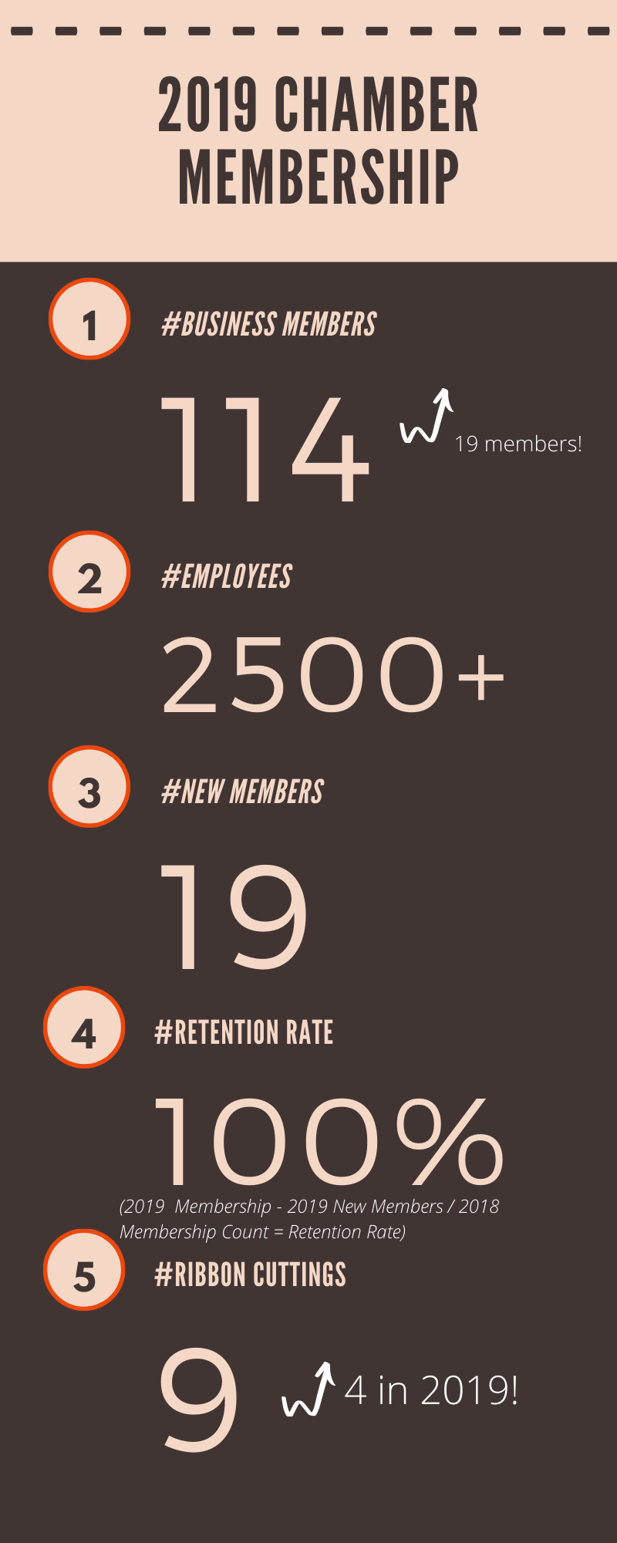

Chamber of Commerce Partners

Here’s a sample of some community partners the Chamber worked with in 2019!

Bustlin’ on Broad
Buzzard Blast
City of Louisville
City of Wadley
City of Wrens

Complete Count Committee
CSRA Regional Commission
Department of Labor
Drugs Don’t Work
Ferst Readers
GA Chamber of Commerce
Jefferson County Commission
Jefferson County Development Authority
Jefferson County High School
Jefferson County Historical Society
Jefferson County Rotary Club
Jefferson Energy Cooperative

Jefferson Hospital
Jefferson Hospital Foundation
Louisville Downtown Development Authority
Louisville Community Food Pantry
Louisville Kiwanis Club
NextSite 360
Oconee Fall Line Technical College
Ogeechee Crossing Park Committee
One-Stop
PSP Group
Queensborough
Region 7 GACCE Executives
SHIPS for Youth
Small Business Development Center
The News and Farmer
Thomas Jefferson Academy
WPEH

2019 Executive Board of Directors

Rosie Burge, Chairman
Bartow Community Club

Parish Howard, Vice-Chairman
The News and Farmer

Brent Dye, Secretary
Integrated Healthcare Resources

Ric Miller, Treasurer
First State Bank

Matt Hodges, Past-President
Oconee Fall Line Technical College

2019 Board of Directors

Randi Beckworth, Mulberry and Magnolia
Tesie Bowles, Queensborough National Bank and Trust Company
Chris Chaffinch, Thomas Jefferson Academy
Sam Dasher, Jefferson County Board of Education
Amber Dowdy, Thomas Jefferson Academy
Jessica Guy, Jefferson Hospital
Tammy Hodges, Jefferson County High School
David Kelly, GA Power
Charles Mathis, Jefferson Energy Cooperative
Rob Swan, Battle Lumber Company

2019 Chairman’s Circle Sponsors
Queensborough National Bank and Trust Company
First State Bank
Battle Lumber Company
Rhodes Murphy
Fulghum Industries
Jefferson Energy Cooperative
This group sponsored ALL 2019 Chamber events.

Gold Sponsors
Pineland Telephone Cooperative
Sponsored Business Builder Series

Magnolia Sponsors
Jefferson County Rotary Club
Louisville Kiwanis Club
Sponsored the STAR Student Luncheon

Georgia Power
Sponsored Resource Expo
Sponsored Leadership Jefferson

Zoom TelCom
Sponsored County Budget Lunch & Learn

Chamber sponsors are committed to providing support for community and business success. Sponsoring Chamber events and programs provides your business publicity and brand recognition at Chamber events while building lasting relationships and allowing you to give back to the community.

2019 Chamber Members

Abbot and Murphy, P.C.
ABC Women's Clinic
AgGeorgia Farm Credit
AP & Judy Jones
Augusta Career Center
Avera Industrial Supply
B&H Land & Timber
Bargeron Insurance Agency, Inc
Bartow Community Club
Battle Lumber Company
BEST Office Solutions
Bethany Farms Bed & Breakfast
BeThere Computer Services
Better Business Bureau
Blackmon Outfitters
Broad Street Books
Busy Bee #2
Carver Elementary School
Centenario Mexican Grill
City of Louisville
City of Wadley
City of Wrens
Coastal Processing, LLC
Comfort Creek Nursing & Rehab
Community Health Care Systems, Inc
Comm. Service Board of Middle Ga
Cooper Machine Company, Inc
Country Financial
Dairy Queen
Deer Ridge Farms, Inc
Delta Termite & Pest Control, Inc
Democratic Party of Jefferson County
Direct Furniture Outlet
Don & Stephanie Bray
Durant Property Rental
Elliott Davis
Farmers Home Furniture
Felicia's Hot Wings and More
First State Bank
Fraser Roofing, LLC
Free Fountain Group, LLC
Fulghum Industries, Inc.
G. Ben Turnipseed Engineers
GA Power
Gatherings on Broad
Giesbrecht HVAC Inc
Head Capital Advisors
Home Fresh Bistro
Huddle House Louisville
Integrated Healthcare Resources
Jays Ace Hardware
Jefferson Co. Auction & Liquidation
Jefferson County Board of Edu.
Jefferson County High School
Jefferson County Historical Society
Jefferson County Library System
Jefferson County Rotary Club
Jefferson Energy Cooperative
Jefferson Hospital
Jet Food Stores of Georgia, Inc
Julian Foley
Kamin, LLC
LA Brett & Sons, Inc
Lee Lewis
Louisville Academy
Louisville AR Presbyterian Church
Louisville Finance Company
Louisville Food Pantry
MB Jones Oil Company, Inc
McDonalds
Meybohm Real Estate
Mulberry and Magnolia
New Way Christian Church
North Jefferson Family Y
Oconee Fall Line Technical College
Peachtree Plaza of Louisville
PEV Invest. dba Wrens Huddle House
Pringle Photography
Producers Peanut
Pruitt Health - Old Capitol
PSP Group
Queensborough National Bank and Trust Company
Rachels Machine and Fabrication, Inc
Randi's Flowers and Gifts
Rhodes Murphy Income Tax Service
Roger & Rosie Burge
Rollin's Landscape Company, Inc.
Shepherd Community Blood Center
SHIPS for Youth / Family Connections
Something Wonderful
St. Mary Magdalene Episcopal Church
State Farm Insurance Agency
State Farm Insurance Agency
Swan Pharmacy
Sweet Tee's Monogram Boutique
Taylor Funeral Home
Team Universe Cheer Louisville
The Arts Guild of Jefferson County
The Communication Coach
The Guest House on Academy
The Louisville Garden Club
The News and Farmer
Thiele Kaolin Company
Thomas Jefferson Academy
Trevathan Goat
Twisted Sisters
Wadley Family Dental
Wasden Realty, Inc
Whitestone Transportation, LLC
WPEH
Wrens Chapel AME Church
Yeomans & Associates Agency, Inc
Zoom Telcom LLC
Zora's Place, LLC

2019 New Chamber Members

Wrens Chapel AME Church
Free Fountain Group, LLC
El Centenario Mexican Grill
PSP Group
Sweet Tee’s Monogram Boutique
Pringle Photography
Community Service Board of Middle Georgia
Blackmon Outfitters
Church of St. Mary Magdalene
Fraser Roofing, LLC
Whitestone Transportation
Julian Foley
JC Auction and Liquidation
Team Universe Cheer
Wadley Family Dental
Busy Bee #2
CSRA Better Business Bureau
Taylor Funeral Home
The Communication Coach
Lee Lewis
Don & Stephanie Bray
Huddle House – Wrens
Felicia’s Hot Wings and More
Elliott Davis, LLC
Zora’s Place
Broad Street Books
Meybohm Real Estate

